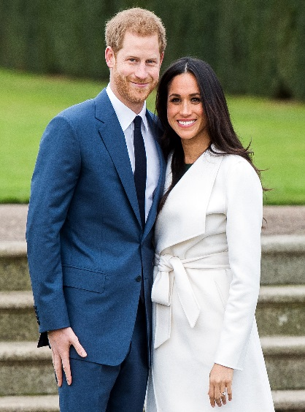

A Royal Celebration Lunch 17th May 2018
This Thursday at Grove Academy we will be celebrating Harry and Megan’s marriage by providing a Royal Banquet and a free school lunch for all children on this day.
Please see the menu below.
.

Main
Roast Turkey & Stuffing or Pizza Slice
Served with a choice of potatoes
And vegetables
Dessert
Choice of cupcake or shortbread
served with a choice of drink

Please note: If there are any special dietary requirements which you may feel we are unaware of then please call the school office as soon as possible.

