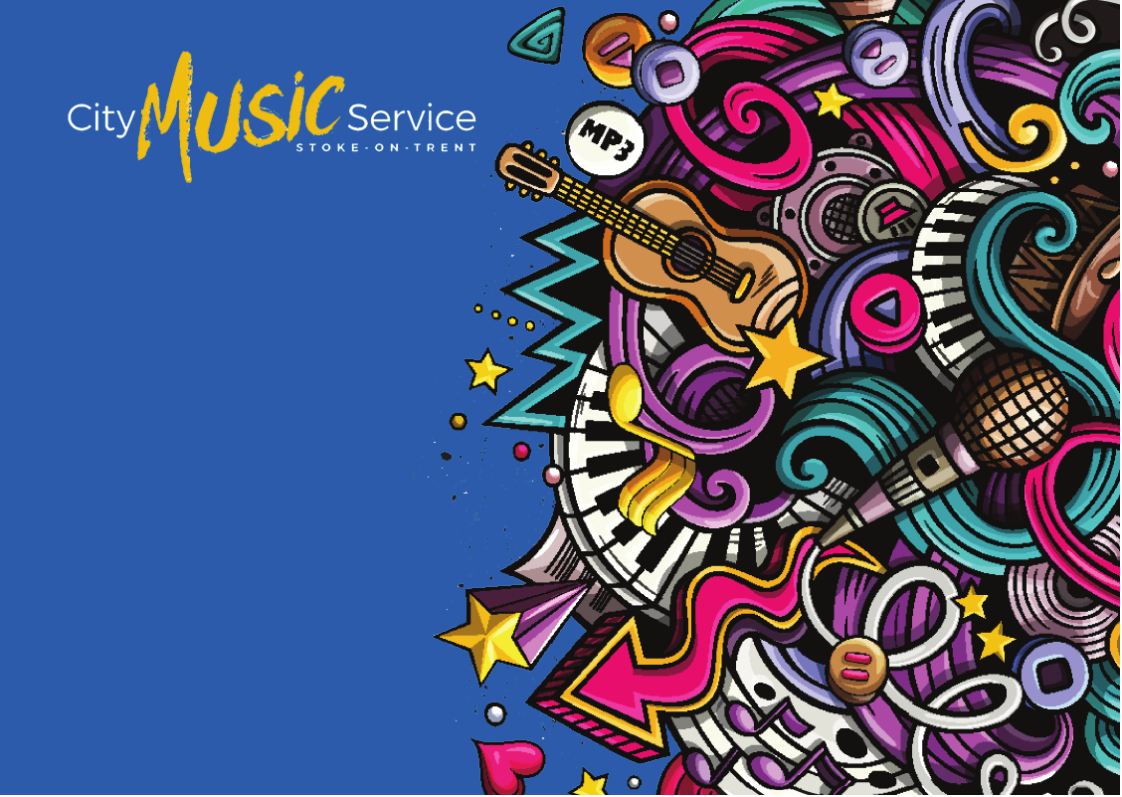

presents

Sessions
Thursday evenings 5.45 - 7.15pm

The Bridge Centre
Birches Head Road, Birches Head, Stoke-on-Trent, ST2 8DD

stoke.gov.uk

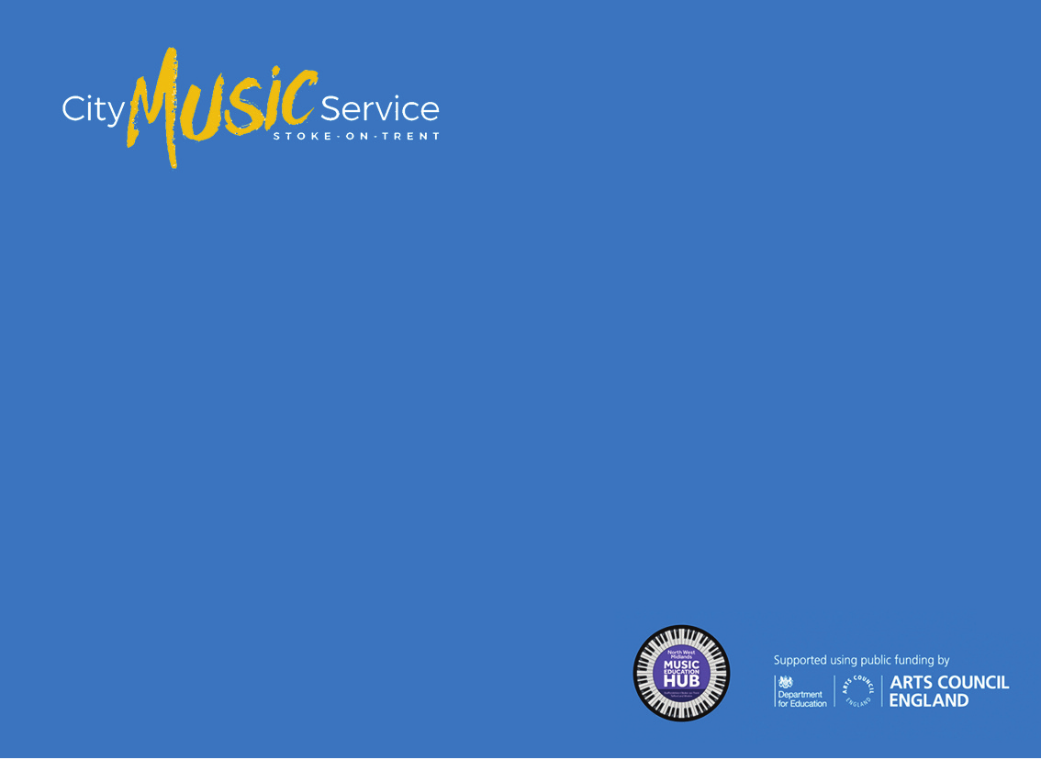
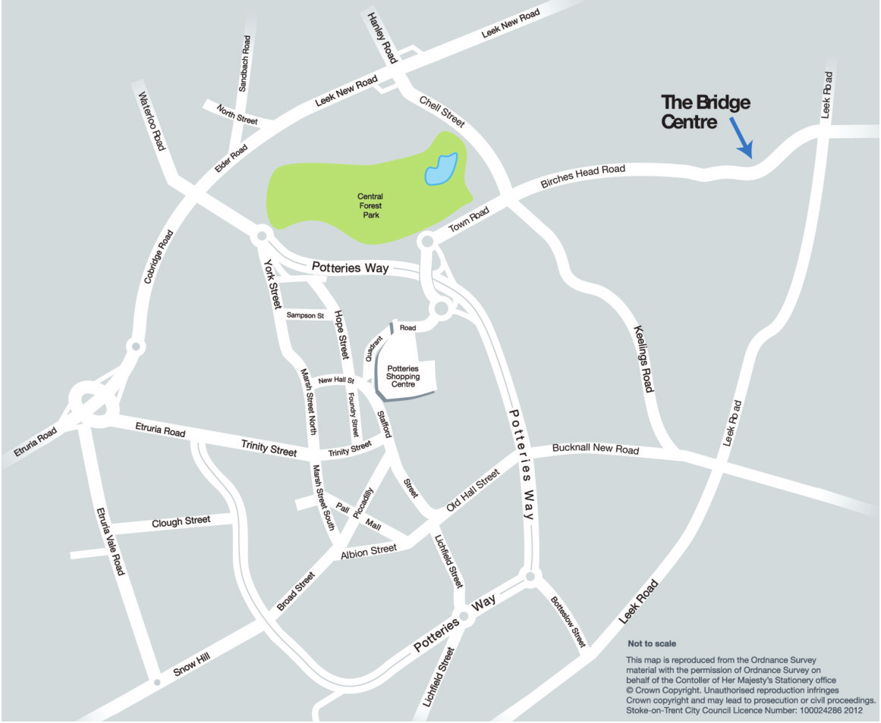

presents

Sessions
Thursday evenings 5.45 - 7.15pm

The Bridge Centre
Birches Head Road, Birches Head,
Stoke-on-Trent, ST2 8DD (Sat nav users please use ST1 6NA)

• Sessions take place onThursday evenings, during term time from 5.45-7.15pm
•The Bridge Centre, Birches Head Road, Birches Head, Stoke-on-Trent, ST2 8DD
• No cost
• Performance opportunities for young people

stoke.gov.uk

If you require any further information please contact the City Music Service on 01782 233796

