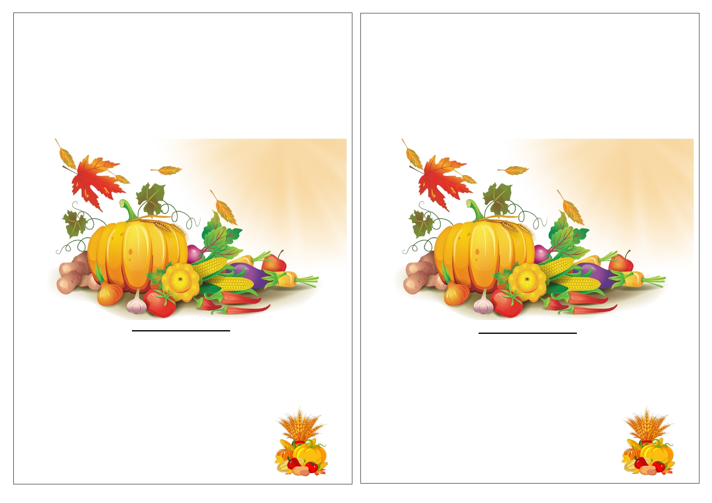
Y3 Harvest Festival
We would like you to join us at Grove Academy on Wednesday
17th October at 9:30am for our Traditional Harvest Festival.
Please return the reply slip by Friday 12th October 2018.
1 ticket per family.
Y3 Harvest Festival
We would like you to join us at Grove Academy on Wednesday
17th October at 9:30am for our Traditional Harvest Festival.
Please return the reply slip by Friday 12th October 2018.
1 ticket per family.

Please note, due to Health and Safety, we will be unable to accommodate
younger siblings. We are sure that we have your understanding and support in
ensuring the safety of children at all times.
_____________________________________________
Y3 Harvest Festival

Childs Name ____________________
Class _________________________

Please note, due to Health and Safety, we will be unable to accommodate
younger siblings. We are sure that we have your understanding and support in
ensuring the safety of children at all times.
_______________________________________________
Y3 Harvest Festival

Childs Name ____________________
Class _________________________

